Certificate of Completion
The following is the student completion certificate. You can use standard 8.5” X 11” certificate paper from you local office supply store. Then simply change the 1: Student’s name 2. Date 3. Instructor’s name.
This certificate is presented to
Sarah Matthews

on March 15, 2025

in recognition of outstanding participation in and completion of
the eight-week biblical discipleship training class

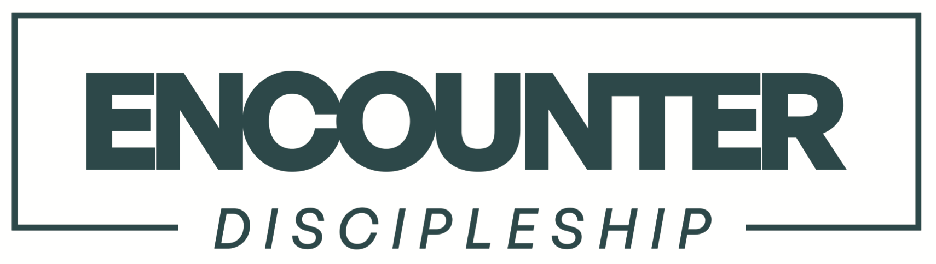

An interactive biblical discipleship program equipping believers
to experience the power, presence, and love of God.

Jarred D. Fenlason, D.Min.
Instructor

